PE01085_BD06630_BD00013_

**EDEXCEL LEVEL 3 BTEC ‘SPORT’**

|  |
| --- |
| **UNIT NUMBER** 1 |
| **UNIT TITLE** PRINCIPLES OF ANATOMY & PHYSIOLOGY IN SPORT |
| **CREDIT VALUE** 5 |
| **ASSESSOR** |

You have been asked by the Head of PE to prepare some material that could be used for key stage 4 students. It is hoped that the work could be displayed in either the PE or Science teaching rooms and be used as visual guidance for the students in their coursework and revision. The work should be presented as a set of display posters, with additional supplementary sheets where necessary. The material will look at the 4 major systems in the body.

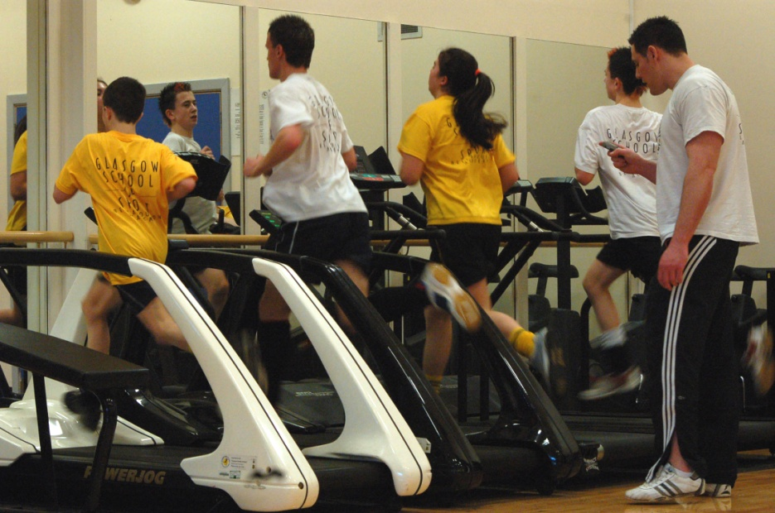 PE01085_BD06630_BD00013_

**EDEXCEL LEVEL 3 BTEC ‘SPORT’**

|  |  |  |
| --- | --- | --- |
| **UNIT NUMBER:** 1 | **UNIT TITLE:**  PRINCIPLES OF ANATOMY & PHYSIOLOGY IN SPORT | |
| **CREDIT VALUE**: 5 | **ASSIGNMENT NO:**1 | |
| **ASSESSOR** | **INTERNAL VERIFIER** | |
| **ISSUE DATE** | **SUBMISSION DATE** | |
| **LEARNING OUTCOMES**  ‘Know the structure and function of the skeletal system’  ‘Know the structure and function of the muscular system’ | | **GRADING CRITERIA**  P1, P2, P3, P4, M1, D1. |

**Tasks:**

* Describe the structure and function of the skeletal system. **P1**

***Structure of skeletal system***: *axial skeleton; appendicular skeleton; types of bone (long bones, short bones,*

*flat bones, irregular bones, sesamoid bones); location of major bones (cranium, clavicle, ribs, sternum,*

*humerus, radius, ulna, scapula, ilium, pubis, ischium, carpals, metacarpals, phalanges, femur, patella, tibia,*

*fibula, tarsals, metatarsals, vertebral column – cervical, thoracic, and lumbar vertebrae, sacrum, coccyx)*

***Function of skeletal system***: *support; protection; attachment for skeletal muscle; source of blood cell*

*production; store of minerals*

* Describe the different classifications of joints. **P2**

***Joints***: fixed; slightly moveable; synovial/freely moveable (types, structures, movement at each joint)

PE01085_BD06630_BD00013_

* Identify the location of the major muscles in the human body **P3**

***Muscular system***: *major muscles (biceps, triceps, deltoids, pectoralis major, rectus abdominis, rectus*

*femoris, vastus lateralis, vastus medialis, vastus intermedius, semimembranosus, semitendinosus, biceps*

*femoris, gastrocnemius, soleus, tibialis anterior, erector spinae, teres major, trapezius, latissimus dorsi,*

*obliques, gluteus maximus); function; location; types of muscle (cardiac, skeletal, smooth)*

* Describe the function of the muscular system and the different muscle types. **P4**
* Further explain (M1) and analyse (D1) the function of the muscular system and the different muscle types. **M1, D1**

***Function of the muscular system***: *movement – antagonistic pairs (agonist, antagonist); fixator; synergist;*

*types of contraction (isometric, concentric, eccentric, isokinetic)*

***Fibre types***: *Type 1; Type 2a; Type 2b; characteristics; types of sports each are associated with*

PE01085_BD06630_BD00013_

**EDEXCEL LEVEL 3 BTEC ‘SPORT’**

|  |  |  |
| --- | --- | --- |
| **UNIT NUMBER:** 1 | **UNIT TITLE:**  PRINCIPLES OF ANATOMY & PHYSIOLOGY IN SPORT | |
| **CREDIT VALUE**: 5 | **ASSIGNMENT NO:**2 | |
| **ASSESSOR** | **INTERNAL VERIFIER** | |
| **ISSUE DATE** | **SUBMISSION DATE** | |
| **LEARNING OUTCOMES**  ‘Know the structure and function of the cardiovascular system’  ‘Know the structure and function of the respiratory system’ | | **GRADING CRITERIA**  P5, M2 |

**Tasks:**

* Describe (P5) and explain (M2) the structure and function of the cardiovascular system. **P5, M2**

***Structure of the cardiovascular system****: heart (atria, ventricles, bicuspid valve, tricuspid valve, aortic valve, pulmonary valve, aorta, vena cava – superior and inferior, pulmonary vein, pulmonary artery); blood vessels (arteries, arterioles, capillaries, veins, venuoles)*

***Function of the cardiovascular system****: delivery of oxygen and nutrients; removal of waste products; thermoregulation (vasodilation and vasoconstriction of vessels); function of blood (oxygen transport, clotting, fighting infection)*

PE01085_BD06630_BD00013_

* Describe (P6) and explain (M3) the structure and function of the respiratory system. **P6, M3**

***Structure of the respiratory system****: nasal cavity; epiglottis; pharynx; larynx; trachea; bronchus; bronchioles; lungs (lobes, pleural membrane, thoracic cavity, visceral pleura, pleural fluid, alveoli); diaphragm; intercostal muscles (external and internal)*

***Function:*** *gaseous exchange; mechanisms of breathing (inspiration and expiration); lung volumes, eg tidal volume, vital capacity, residual volume; control of breathing (neural and chemical)*

PE01085_BD06630_BD00013_

**EDEXCEL LEVEL 3 BTEC ‘SPORT’**

|  |  |  |
| --- | --- | --- |
| **UNIT NUMBER:** 1 | **UNIT TITLE:**  PRINCIPLES OF ANATOMY & PHYSIOLOGY IN SPORT | |
| **CREDIT VALUE**: 5 | **ASSIGNMENT NO:**3 | |
| **ASSESSOR** | **INTERNAL VERIFIER** | |
| **ISSUE DATE** | **SUBMISSION DATE** | |
| **LEARNING OUTCOME**  ‘Know the different types of energy systems’ | | **GRADING CRITERIA**  P7, M4, D2 |

Your posters have been well received by students studying for both GCSE PE & Science. You are now to plan a practical exercise which will improve their understanding of the energy systems.

**Tasks:**

* Describe the three different energy systems and an example of a sport or activity where each of the systems is used. **P7**
* Further explain (M4) and analyse (D2) the three different energy systems and their use in sport and exercise activities. **M4, D2**

***Energy systems****: phosphocreatine; lactic acid system; aerobic energy system; amount of ATP*

*Produced by each system; sports that use these systems to provide energy;*

**BTEC ‘SPORT’ASSIGNMENT BRIEF I/V**

**UNIT PRINCIPLES OF ANATOMY LEVEL 3 AND PHYSIOLOGY IN SPORT**

### 

* HAS ACCURATE PROGRAMME & UNIT DETAILS YES/NO

* HAS CLEAR DEADLINES FOR ASSESSMENT YES/NO
* SHOWS ALL RELEVANT GRADING CRITERIA

FOR THE UNIT(S) COVERED IN THE ASSIGNMENT YES/NO

* INDICATES RELEVANT GRADING CRITERIA

TARGETED AGAINST EACH TASK YES/NO

* CLEARLY STATES WHAT EVIDENCE THE

LEARNER NEEDS TO PROVIDE YES/NO

* IS LIKELY TO GENERATE EVIDENCE WHICH

IS APPROPRIATE AND SUFFICIENT YES/NO

* HAS A TIME PERIOD OF APPROPRIATE DURATION YES/NO
* IS SET AT THE APPROPRIATE LEVEL YES/NO
* USES SUITABLE VOCATIONAL LANGUAGE YES/NO
* HAS A CLEAR PRESENTATION FORMAT YES/NO

**GENERAL FEEDBACK**

### SIGNED \_\_\_\_\_\_\_\_\_\_\_\_\_\_\_\_\_\_ I/V) DATE \_\_\_\_\_\_\_\_\_\_\_\_\_\_\_\_\_

**REMEDIAL ACTION COMPLETED (IF APPROPRIATE)**

### SIGNED \_\_\_\_\_\_\_\_\_\_\_\_\_\_\_\_\_\_ ASSESSOR) DATE \_\_\_\_\_\_\_\_\_\_\_\_\_\_\_\_\_

PE01085_BD06630_BD00013_

**UNIT 1 – PRINCIPLES OF ANATOMY AND PHYSIOLOGY IN SPORT**

**OUTLINE LEARNING PLAN (30 G.L.H.)**

**Introduction and overview of the unit**

**Assignment 1: The Skeletal & Muscular Systems (P1, P2, P3, P4, M1, D1). Suggested time – 12 Guided Learning Hours.**

* Tutor introduces the unit and assignment brief.
* Structure of skeletal system: major bones of the skeletal system are taught – labelled diagrams and disarticulated skeleton
* Function of skeletal system: theory and DVD
* Joint structure and function of the different types of joints: interactive lecture and learner activities in small groups
* Major muscles: diagrams and sticky label game
* Fibre types and characteristics of each: learner-centred research
* Antagonistic pairs and different types of muscle contraction – practical session
* Students prepare and complete assignment.

**Assignment 2: The Cardiovascular & Respiratory Systems (P5, P6, M2, M3). Suggested time – 12 Guided Learning Hours**

* Tutor introduces the assignment brief.
* Structure of the heart – theory and practical dissection
* Blood vessels and blood: learners work in small groups and are given one type of blood vessel to research – present their findings to the rest of the group
* Structure of the respiratory system: theory and practical making a model of the respiratory system
* Function of the respiratory system DVD: gaseous exchange and the mechanism of breathing
* Respiratory volumes: practical investigation using a spirometer
* Neural and chemical control of breathing: tutor-led lesson and practical investigation
* Students prepare and complete assignment

**Assignment 3: Energy Systems.**

**Suggested time – 6 Guided Learning Hours**

* Tutor introduces the assignment brief.
* Phosphocreatine energy system and lactic acid system: theory and practical lesson
* Aerobic energy system: theory and practical tasks
* Students prepare and complete assignment

**Review of unit and assessment activities.**