PE01085_BD06630_BD00013_

**EDEXCEL LEVEL 2 BTEC ‘SPORT’**

|  |
| --- |
| **UNIT NUMBER:** 1 |
| **UNIT TITLE:** FITNESS TESTING  AND TRAINING |
| **CREDIT VALUE:** 5 |
| **ASSESSOR:** |

## The school have a number of gifted and talented athletes in a range of sports. You are to produce some material that will help these athletes to keep fit for their selected sport throughout their time at secondary school. We are expecting to display some of this material on the school notice boards.

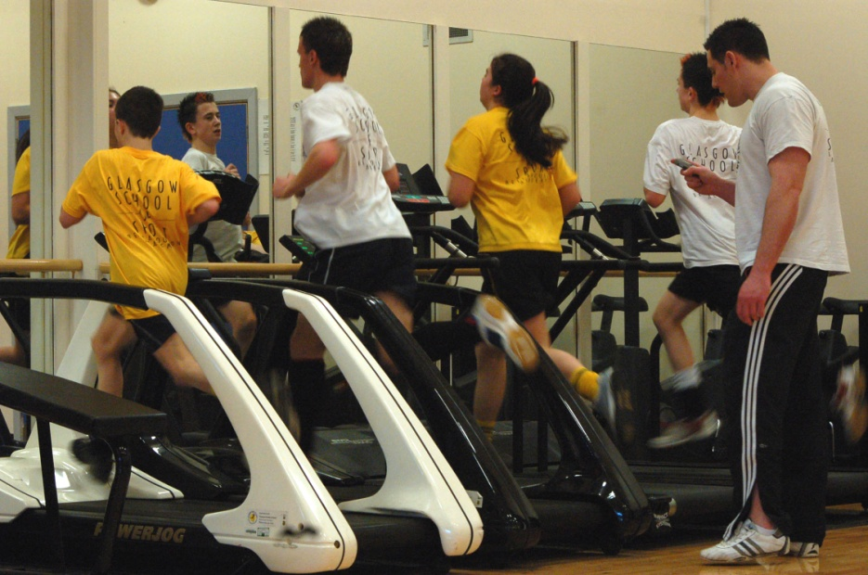 PE01085_BD06630_BD00013_

**EDEXCEL LEVEL 2 BTEC ‘SPORT’**

|  |  |  |
| --- | --- | --- |
| **UNIT NUMBER:** 1 | **UNIT TITLE:**  FITNESS TESTING AND TRAINING | |
| **CREDIT VALUE**: 5 | **ASSIGNMENT NO:** 1 | |
| **ASSESSOR** | **INTERNAL VERIFIER** | |
| **ISSUE DATE** | **SUBMISSION DATE** | |
| **LEARNING OUTCOME**  ‘Know the fitness and training requirements necessary to achieve excellence in a selected sport’ | | **GRADING CRITERIA**  P1 P2 M1 |

**Tasks:**

You are to select one of our talented athletes within school and produce a poster which could be displayed in the changing rooms. This poster should:

* Describe the fitness requirements for achieving excellence in the selected sport

**P1**

*Reference must be made to the following components of fitness: physical fitness (aerobic endurance, muscular endurance, flexibility, speed, strength, body composition); skill-related fitness (agility, balance, coordination, power, reaction time)*

* Explain in more detail the importance of the components of fitness for the selected sport **M1**
* Describe three different fitness training methods used to achieve excellence in the selected sport. **P2**

*Fitness training methods: e.g. flexibility training (static, active, passive, ballistic), strength and power training (resistance machines, circuit training, plyometrics, reps, sets and resistance), endurance training (continuous training, fartlek training, interval training, heart rate, training zones), speed and speed endurance (hollow sprints, acceleration sprints, interval training)*

PE01085_BD06630_BD00013_

**EDEXCEL LEVEL 2 BTEC ‘SPORT’**

|  |  |  |
| --- | --- | --- |
| **UNIT NUMBER:** 1 | **UNIT TITLE:**  FITNESS TESTING AND TRAINING | |
| **CREDIT VALUE**: 5 | **ASSIGNMENT NO:** 2 | |
| **ASSESSOR** | **INTERNAL VERIFIER** | |
| **ISSUE DATE** | **SUBMISSION DATE** | |
| **LEARNING OUTCOME**  ‘Know the lifestyle factors that affect sports training and performance’ | | **GRADING CRITERIA**  P3 |

**Tasks:**

Produce one side of A4 which:

* Describes 4 different lifestyle factors that could have an effect on the selected performer’s sports training and performance. **P3**

*Lifestyle factors: e.g. stress, alcohol, smoking, drugs, sleep, demands of work, medical history, level of activity, diet, weight, gender, culture, sports participation (training and competition)*

PE01085_BD06630_BD00013_

**EDEXCEL LEVEL 2 BTEC ‘SPORT’**

|  |  |  |
| --- | --- | --- |
| **UNIT NUMBER:** 1 | **UNIT TITLE:**  FITNESS TESTING AND TRAINING | |
| **CREDIT VALUE**: 5 | **ASSIGNMENT NO:** 3 | |
| **ASSESSOR** | **INTERNAL VERIFIER** | |
| **ISSUE DATE** | **SUBMISSION DATE** | |
| **LEARNING OUTCOME**  ‘Be able to assess their own level of fitness’ | | **GRADING CRITERIA**  P4, P5, M2, D1 |

**Tasks:**

You are helping to provide some data that could be used to produce some standardised tables for performance in a variety of fitness tests. To be able to do this you need to take part in a variety of tests.

* Participate in four different fitness tests that measure different components of fitness, recording all of your own results accurately. An observation record is required from your tutor as evidence that you have completed all of these tests **P4**

*Fitness tests: e.g. flexibility (sit and reach test, goniometers), strength (one-repetition maximum (1RM), grip dynamometer), aerobic endurance (multi-stage fitness test, Chester step test), speed (40 m sprint), power (vertical jump, Wingate test), muscular endurance (one-minute press-up, one-minute sit-up), body composition (skinfolds, bioelectrical impedance analysis, body mass index*)

* Interpret your test results by comparing them against normative data and what you would need to achieve to compete at the highest level ([www.brianmac.co.uk](http://www.brianmac.co.uk)**) P5**
* Explain in more detail your test results and personal level of fitness, identifying strengths and areas for improvement. **M2**
* Evaluate your test results and personal level of fitness by comparing with the level required to compete at the highest level. **D1**

PE01085_BD06630_BD00013_

**EDEXCEL LEVEL 2 BTEC ‘SPORT’**

|  |  |  |
| --- | --- | --- |
| **UNIT NUMBER:** 1 | **UNIT TITLE:**  FITNESS TESTING AND TRAINING | |
| **CREDIT VALUE**: 5 | **ASSIGNMENT NO:** 4 | |
| **ASSESSOR** | **INTERNAL VERIFIER** | |
| **ISSUE DATE** | **SUBMISSION DATE** | |
| **LEARNING OUTCOME**  ‘Know the effects of psychological factors on sports training and performance’ | | **GRADING CRITERIA**  P6, M3, D2 |

**Tasks:**

Your final task is to provide the gifted and talented students with some guidance on the importance of psychology on their training and performance.

* Complete the enclosed chart which provides guidance for the students on how a variety of psychological factors can affect their training and performance. A description achieves **P6**, an explanation **M3** and an analysis **D2 P6, M3, D2**

***Factors:*** *motivation; arousal and anxiety; personality; concentration*

***Effects****: short term e.g. increased motivation, activate athletes towards targets and goals; long term e.g.*

*Maintenance of targets and goals, improved sports performance*

PE01085_BD06630_BD00013_

**EDEXCEL LEVEL 2 BTEC ‘SPORT’**

**UNIT 1 FITNESS TESTING & TRAINING - ASSIGNMENT 4**

|  |  |
| --- | --- |
| **FACTOR** | **EFFECT ON TRAINING & PERFORMANCE.** |
| **MOTIVATION** |  |
| **AROUSAL &**  **ANXIETY** |  |
| **PERSONALITY** |  |
| **CONCENTRATION** |  |

***This worksheet can be downloaded from student learning resources***.

###### BTEC ‘SPORT’ASSIGNMENT BRIEF I/V

**UNIT FITNESS TESTING AND TRAINING LEVEL 2**

### 

* HAS ACCURATE PROGRAMME & UNIT DETAILS YES/NO

* HAS CLEAR DEADLINES FOR ASSESSMENT YES/NO
* SHOWS ALL RELEVANT GRADING CRITERIA

FOR THE UNIT(S) COVERED IN THE ASSIGNMENT YES/NO

* INDICATES RELEVANT GRADING CRITERIA

TARGETED AGAINST EACH TASK YES/NO

* CLEARLY STATES WHAT EVIDENCE THE

LEARNER NEEDS TO PROVIDE YES/NO

* IS LIKELY TO GENERATE EVIDENCE WHICH

IS APPROPRIATE AND SUFFICIENT YES/NO

* HAS A TIME PERIOD OF APPROPRIATE DURATION YES/NO
* IS SET AT THE APPROPRIATE LEVEL YES/NO
* USES SUITABLE VOCATIONAL LANGUAGE YES/NO
* HAS A CLEAR PRESENTATION FORMAT YES/NO

**GENERAL FEEDBACK**

### 

### SIGNED \_\_\_\_\_\_\_\_\_\_\_\_\_\_\_\_\_\_\_(I/V) DATE \_\_\_\_\_\_\_\_\_\_\_\_\_\_\_\_\_

**REMEDIAL ACTION COMPLETED (IF APPROPRIATE)**

### SIGNED \_\_\_\_\_\_\_\_\_\_\_\_\_\_\_\_\_\_\_(ASSESSOR) DATE \_\_\_\_\_\_\_\_\_\_\_\_\_\_\_\_\_

PE01085_BD06630_BD00013_

**UNIT 1 - FITNESS TESTING & TRAINING**

**OUTLINE LEARNING PLAN (30 G.L.H.)**

**Introduction and overview of the unit**

**Assignment 1: Fitness and Training for Sporting Excellence**

**(P1, M1, P2)** **Suggested time – 10 Guided Learning Hours**

* Tutor introduces the unit and assignment brief.
* Students select a student and a sport and explore the fitness requirements and training methods needed to achieve excellence
* Research the following components of fitness - physical fitness (aerobic endurance, muscular endurance, flexibility, speed, strength, body composition); skill-related fitness (agility, balance, coordination, power, reaction time) – ***and relate to selected sport***
* Explore training methods through practical participation. Fitness training methods: e.g. flexibility training (static, active, passive, ballistic), strength and power training (resistance machines, circuit training, plyometrics, reps, sets and resistance), endurance training (continuous training, fartlek training, interval training, heart rate, training zones), speed and speed endurance (hollow sprints, acceleration sprints, interval training) – ***and relate to selected sport***
* Students prepare and complete assignment poster.

**Assignment 2: Exploring Lifestyle Factors**

**(P3)** **Suggested time – 4 Guided Learning Hours**

* Tutor introduces the assignment brief.
* Tutor covers one lifestyle factor per lesson – e.g. drugs / alcohol, stress, activity levels, diet and weight, culture – but encourage students to research own.
* Students select four different lifestyle factors and describe how these affect sports training and performance.
* Students prepare and complete assignment.

**Assignment 3: Assessing Fitness Levels**

**(P4, P5, M2, D1)** **Suggested time – 10 Guided Learning Hours**

* Tutor introduces the assignment brief.
* Personal fitness levels assessed by participation in four different fitness tests for different components of fitness. Students to record own results.
* Before each one discuss how to conduct each test and afterwards compare own results against data from [www.brianmac.co.uk](http://www.brianmac.co.uk) > performance tests.
* How to interpret results and to work out individual strengths and weaknesses.
* Students prepare and complete assignment.

**Assignment 4: Exploring Psychological Factors**

**P6, M3, D2**. **Suggested time – 6 Guided Learning Hours**

**`**

* Tutor introduces the assignment brief.
* Learners explore psychological factors and their effects on sports training and performance.
* Students examine personality traits: administer personality questionnaire and interpret results.
* Concentration and the Sports Performer – DVD
* Students explore motivation, arousal and anxiety: effects on sports training and performance.
* Students complete worksheet for assignment.

**Review of unit and assessment activities**